Detecting human-written and AI-generated English text
This paper provides a comparative review of traditional and deep learning models for AI text detection, providing real-world practicability insights. It offers an answer to the problem of distinguishing between human and AI-generated content, a pertinent problem with today's supercomputing generation models like GPT-3.5 and GPT-4. The objectives were to contrast prevalent detection approaches, acquire and prepare different datasets, and try several models to contrast performance.
Our strategy was to create and test BERT, TF-IDF, Linear Discriminant Analysis (LDA), and hybrid models with the application of the conventional machine learning methods. We applied Natural Language Processing (NLP) preprocessing, feature engineering, and tested each model's strengths, weaknesses, and accuracy.
The results indicate that BERT-based models produced the highest accuracy rate of 97.44%, followed by Linear SVM using TF-IDF at 96%, and Random Forest using LDA features at 94%. The results contribute to ongoing research in guaranteeing content authenticity on online platforms.

This work provides a comparative evaluation of traditional and deep learning models for AI text detection, offering insights into their practical deployment .The rapid advancement of generative AI models, particularly OpenAI’s GPT-3.5 and GPT-4, has blurred the distinction between human-written and machine-generated text, posing significant challenges to academic integrity, journalism, and digital content moderation. This book offers a methodical comparative study of traditional and deep learning models for AI text detection, responding to the pressing need for reliable classification methods.
We began by analyzing existing detection methods to understand their demerits and merits. We then collected and preprocessed a number of datasets comprising human-written as well as AI-generated text. Using these datasets, we trained and cross-checked various models, including a fine-tuned BERT classifier, Linear SVM using TF-IDF features, and a Random Forest model trained on LDA topic distributions. We checked each of the models on key performance measures—accuracy, precision, recall, and F1-score—to understand their suitability in real-world applications.
Our quantitative results revealed that the BERT-based model achieved the best accuracy at 97.44%, with Linear SVM with TF-IDF coming in second at 96% and Random Forest with LDA at 94%. The results demonstrate the power of transformer-based models to identify fine-grained linguistic structure native to AI-generated text, while also highlighting trade-offs in computational expense and interpretability among methods.
This work advances current research in ensuring digital content authenticity and offers recommendations for implementing AI text detection systems in real-world applications. Future research can investigate hybrid models and adaptive detection methods to stay ahead of changing generative AI capabilities
1. Introduction

1.1 Overview
The rapid development of artificial intelligence, especially in the natural language generation, has been able to create a powerful equipment that is able to build text that is often unique from written by humans. Large language models such as Openis GPT-3.5 and GPT-4 have shown a unique ability to generate relevant, relevant and stylistically natural prose. While these are developing with new doors in automation, material production and productivity, they also face challenges in authenticity confirmation and digital trust.
In academia, students can use AI to generate essays or answers, which arouse serious concerns about literary theft and intellectual dishonesty. In journalism, AI-related content can contribute to misinformation, fake news and erosion of public trust. In cyber security, malicious actor can benefit from these techniques to produce fishing -e -mail, promotion or resolution campaigns on a scale. As a result, it is the opportunity to find out if a given text has been a human-written or AI-generated, it has become a priority in many subjects.
The project wants to develop and address these implications by developing and evaluating strong detection models that can help reduce the abuse of generative AI technologies.

1.2 Motivation
As the generative AI models become sophisticated quickly, the line between human-written and machine-cleaning text is blurred. These are important challenges in different domains:

• Academic dishonesty: Students can submit the AI-rendered essays or tasks by reducing the learning process and compromising educational integrity.
• Error information: AI equipment can produce misleading or false content that seems reliable, and contributes to the spread of fake news and public confusion.
• Fishing and online attacks: Only player can take advantage of AI, who can crafts to secure fishing - post or social engineering messages, which increases the risk of breakdown of data and financial fraud.
These risks highlight the immediate requirement for reliable identification tools that can identify AI-related text and help preserve trust, security and justice in digital communication.

1.3 Problem description
The AI-related lesson often mimics as a traditional literary theft tool fails to identify it. It faces challenges in academics, publishing and information authenticity. Strong, scalable systems require that can distinguish between AI and human -powered materials.

1.4 Scope and purpose
The main goal of this project is to design and evaluate the model that is able to detect AI-based text with high accuracy and reliability. The project focuses on English-language content, especially on essays, and examines the application of machine learning and natural language treatment techniques to distinguish between human-written and AI-related text. To achieve this, the project involves an intensive review of existing research articles and detection equipment, followed by procurement and front of different data sets. Many models are used andevaluated, including BERT for deep contextual understanding, LDA combined with Random Forest for topic-based classification, and TF-IDF with Support Vector Machine for statistical feature-based detection. The performance of these models is compared using standard evaluation metrics, and the results are used to develop recommendations that can guide future work in the field of AI text detection.

1.5 Report Organization
This report is structured into seven chapters. Chapter 2 reviews related work. Chapter 3 discusses data acquisition and preprocessing. Chapter 4 presents the models used. Chapter 5 evaluates their performance. Chapter 6 summarizes results, and Chapter 7 provides conclusions and suggestions for future work.

1.6 Work Methodology
The project followed a systematic and structured approach to ensure consistent and reliable results. This began with a comprehensive literature review to understand today's progress, boundaries and trends to detect the AI ​​text. This was followed by several datasets, and both AI-borne and human-written texts were included. The data then goes through the Preprocessing layer to clean, normalize and balance them for training purposes. Subsequently, several machine learning models were developed and nicely canceled, including Burt, LDA, LDA with random forest and TF IDF with a supporting vector machine. Each model was evaluated using standard performance measurements to determine efficiency. Finally, the findings were analyzed and documented, used to generate practical recommendations and insights for future research and implementation with results.
2. Related Work (State-of-The-Art)

2.1 Background
The task of detecting AI-generated text has gained prominence with the rise of large language models (LLMs) such as GPT-2, GPT-3.5, and GPT-4. Traditional plagiarism detection systems like Turnitin are often ineffective in distinguishing AI-written content from human-authored text due to the fluency and coherence of LLM outputs. Consequently, researchers have turned to machine learning and natural language processing (NLP) to address this issue.

2.2 Literature Survey
Current studies have become increasingly worried about the challenges and approaches of detecting AI-generated text, particularly with the advent of large language models like ChatGPT. In [1], researchers examined the performance of various AI detectors in evaluating the output of ChatGPT-3.5 and GPT-4 and established that while tools achieved high scores on GPT-3.5 (with as much as 93% accuracy), the sophistication of GPT-4 poses a considerable challenge to precise detection. Similarly, [2] presented BERT-based models achieving high 97% accuracy and low train-test performance gaps, emphasizing data scaling and feature engineering strengths. Traditional plagiarism programs Copyleaks, TurnItIn, and Originality.ai were compared in [3] beating other programs with over 83% accuracy for GPT-4 content, though most programs struggled with the advanced outputs. A qualitative analysis by [4] recommended a hybrid, cost-saving approach starting with feature-based detection and falling back to watermarking for more ambiguous cases. Model diversity has been explored in some other work: [5] achieved near-perfect F1-scores (up to 0.9993) when submitting handcrafted features to Random Forest and XGBoost, while [6] advocated the application of TreeNet, n-gram analysis, and clustering for enhanced robustness.

The impact of input length and generation sampling strategies was emphasized in [7], where fine-tuned RoBERTa achieved 95% accuracy, with performance plummeting on short texts. [8] also remarked that detection accuracy using RoBERTa varied from 58% on short texts to 97% on longer paragraphs, emphasizing input granularity. Comparative studies of BERT, XGBoost, and SVM in [9] placed BERT on top with 93% accuracy, whereas the authors presented ethical considerations on potential misuse of AI-generated content. Explainability was the focus in [10], with Random Forest, XGBoost, and RNN models augmented by LIME with up to 98.5% accuracy and significantly outperforming GPTZero. Multi-language detection was addressed also in [11], where SVM achieved up to 100% accuracy on human essays, and 97.2% macro F2-score, which was efficient for avoiding false negatives.

In a larger and domain-specific work, [12] introduced the Human ChatGPT Comparison Corpus (HC3) with over 85,000 responses in English and Chinese. It examined ChatGPT's ability to mimic human experts in fields such as law, psychology, and medicine. Using a combination of Turing tests, sentiment analysis, and linguistic pattern evaluation, the authors found that ChatGPT answers often outdid human answers in structure and utility—particularly in finance and psychology—but lagged in medical accuracy. Detection models utilized included logistic regression with GLTR features and RoBERTa-based classifiers, with the QA-style RoBERTa achieving a high F1-score of 97.48%. In particular, the study indicated deficiencies in current detection capabilities and recommended further exploration of adversarial prompts, sentence-level classification, and dataset diversification.

Table 1:Papers
Paper Title | Model(s) Used | Accuracy/Performance | Key Findings
Evaluating the Efficacy of AI Detectors[1] | ChatGPT-3.5, ChatGPT-4 | 93% (GPT-3.5), lower for GPT-4 | Detectors struggle with GPT-4-generated text due to its sophistication. Highlights challenges in differentiating AI vs. human text.
AI-Generated Text Detection Based on BERT[2] | BERT | 97% (test set), 0.39% train-test gap | High accuracy and stability. Suggests improvements via data scaling, architecture optimization, and feature engineering.
Effectiveness of Software to Detect AI-Generated Text[3] | Copyleaks, TurnItIn, Originality.ai | Top 3: ~83%+ for GPT-4; others 63–71% | Copyleaks, TurnItIn, and Originality.ai are most reliable for academic use. Most tools fail with GPT-4.
Decoding the AI Pen: Techniques and Challenges[4] | Hybrid (Feature-based, Zero-shot, etc.) | N/A (qualitative) | Proposes a cost-efficient multi-tiered workflow: start with feature-based detection, escalate to watermarking/supervised methods for complex cases.
How to Detect AI-Generated Texts?[5] | Random Forest, XGBoost, SVM | RF/XGB: F1=0.9993; SVM: F1=0.765 | Near-perfect accuracy with handcrafted features (e.g., word density, readability). SHAP analysis identified key discriminative features.
Computer-generated Text Detection Using ML[6] | TreeNet, SVM, n-gram, Clustering | Varies (no specific %) | Current methods are effective but improvable. Suggests combining techniques, improving robustness, and standardizing evaluation metrics.
Automatic Detection of Machine-Generated Text[7] | RoBERTa (fine-tuned), T5, ELECTRA | 95% (RoBERTa) | Challenges with short texts (e.g., reviews). Proposes research on sampling methods (top-k, top-p) to improve detection.
On the Possibilities of AI-Generated Text Detection[8] | RoBERTa-Base/Large-Detector | 58% (short texts) → 97% (paragraphs) | Detection feasibility depends on text length. Emphasizes need for robust detectors and watermarking to address misuse.
Detecting AI-Generated Text with NLP/ML[9] | BERT, XGB, SVM | BERT: 93%; XGB: 84%; SVM: 81% | BERT outperforms others. Highlights ethical concerns around AI-generated content.
Leveraging Explainable AI for LLM Text Attribution[10] | RF, XGBoost, RNN, LIME | RF/XGB: 97–98%; RNN: 94% | Outperformed GPTZero (98.5% vs. 78.3%). LIME provided explainability. Model handled 100% of test data (GPTZero missed 4.2%).
Towards Multi-Language AI-Content Detection[11] | SVM, Ensemble, NN, RF, Logistic Reg. | SVM: 92–100% (human essays); F2=97.2% | SVM achieved 100% accuracy for human essays (no false negatives). Best overall accuracy (92.7%) among tested models.
[12] | RoBERTa, Logistic Regression | 97.48% | RoBERTa is effective in binary classification of human vs ChatGPT responses
  Human–ChatGPT Comparison Corpus (HC3)

2.3 Analysis of the Related Work
From the reviewed literature, several insights can be drawn:
- BERT-based models consistently outperform traditional classifiers.
- Detection becomes significantly harder with shorter texts.
- GPT-4's advanced generation capabilities reduce the effectiveness of many public detection tools.
- Random Forest and XGBoost models using handcrafted features like burstiness and perplexity can rival deep learning models in accuracy.
- Hybrid approaches offer the best trade-off between explainability, cost, and accuracy.
Chapter 3: Data Acquisition and Preparation
The quality and nature of the dataset are crucial when it comes to building effective machine learning models, particularly when working with binary classification issues such as classifying AI-generated vs. human-written text. This chapter discusses the datasets used in this study, their nature, preprocessing, and how imbalances in datasets were addressed.

3.1 Initial Dataset: DAIGT V2 Train Dataset
The primary dataset for the first part of this project was the DAIGT V2 Train Dataset, which can be found publicly on Kaggle. The dataset comprises 44,868 sample essays, including 17,497 AI-generated and 27,371 human-written essays. The dataset was built from a variety of sources and includes text from several large language models (LLMs), offering a diverse range of writing styles. Each row in the data contains columns such as prompt_id (a unique id for each prompt), text (the essay itself), prompt_name (the prompt upon which the text was generated), and label (whether the essay is AI or human-generated). Despite its wealth and size, the dataset was found to contain a high degree of internal similarity, and hence some of the models (i.e., TF-IDF-based classifiers) gave poor generalization performance when evaluated on new samples.

3.2 Supplementary Datasets
To increase diversity and render the model more robust, two other datasets were incorporated into the training pipeline.

3.2.1 LLM – Detect AI Generated Text Dataset
The second supporting dataset, also from Kaggle, is the "LLM - Detect AI Generated Text Dataset." It was built to detect AI-generated content and contains 29,146 essay samples. 11,637 of them are AI-generated and 17,508 are human-generated. The dataset primarily consists of student-written text and includes columns such as text and label, where label specifies whether the sample is human or AI-generated.

3.2.2 HC3 Dataset
The second supplementary dataset is the HC3 dataset, published by Hello-SimpleAI and accessible via Hugging Face. Designed for various natural language processing tasks, this dataset includes approximately 24,300 entries collected from platforms such as Reddit’s “Explain Like I’m Five” (ELI5) and Wikipedia. Key columns include id, question, human_answers, chatgpt_answers, and source. The human and AI-generated responses are particularly useful for binary classification and offer insights into contextual and stylistic differences between the two categories.

3.3 Dataset Concatenation and Analysis
All three datasets were concatenated to create a comprehensive and diverse dataset containing 122,659 essay samples, with 53,456 AI-generated texts and 69,200 human-written texts. An initial analysis of this combined dataset revealed a class imbalance, with human-written content making up approximately 56.4% and AI-generated content accounting for 43.6%. Addressing this imbalance was essential to prevent biased model training and ensure fair evaluation.

3.4 Data Balancing
To mitigate the effects of class imbalance, a balancing strategy was applied to produce a dataset with an equal 50/50 distribution between human and AI-generated texts. This helped prevent model bias toward the majority class and allowed for more reliable evaluation of classifier performance across both categories.

3.5 Alternative Dataset Configuration
In an alternate experiment, the DAIGT-V2 dataset was excluded to test the generalization performance of models trained on only the supplementary datasets. The resulting dataset contained 77,791 samples, with 35,959 AI-generated and 41,829 human-written texts, yielding a near-balanced distribution of 47% AI-generated and 53% human-written content. However, for the final model training and evaluation presented in this report, the fully balanced dataset (50/50 split) was used to ensure fair and consistent performance assessment.

The models we worked on were trained and evaluated using the balanced dataset (50/50 distribution).
4. Models
This chapter outlines the models implemented for detecting AI-generated versus human-written text. Each model employed different features, architectures, and evaluation criteria to explore the most effective detection strategies.
We structured our experiments around four core approaches:
- A transformer-based deep learning model (BERT)
- A topic modeling technique combined with classical ML (LDA + Random Forest)
- A statistical feature-based method (TF-IDF + LinearSVC & Logistic Regression)
- A hybrid approach combining handcrafted and deep features with classical classifiers
4.1 BERT
Figure 3:"Comprehensive Text Classification and Feature Extraction Model Pipeline"
This section explains the building of a deep learning model from the Bidirectional Encoder Representations from Transformers (BERT) architecture to classify texts as either written by human or generated through AI. The process involved a sequential pipeline that was formed through preprocessing, tokenization, model initialization, training, and testing..

4.1.1 Text Preprocessing
To further improve the model's discriminative learning of textual patterns, every input text was passed through a standardized pipeline of preprocessing, which included the following:
- Lowercasing: All characters were converted to lowercase, thus reducing vocabulary size and improving model generalization.
- Punctuation and Number Removal: All punctuation marks and numeric characters were removed from the text using regular expressions and string manipulation tools.
- HTML Artifact Elimination: Trailing HTML character codes (e.g., &nbsp;) were eliminated for the sake of text cleanliness.
- Non-ASCII Character Elimination: Any non-standard ASCII characters were eliminated to reduce encoding noise.
- Whitespace Normalization: Excess spaces, tabs, and newlines were flattened into single spaces to preserve formatting integrity.
Note: Unlike traditional preprocessing procedure in standard NLP applications, stopwords were intentionally not removed. The reason behind this is that the transformer models, such as BERTs, require a full linguistic context to capture semantic relationships. Deleting stopwords may inhibit the model from understanding the structure and meaning of sentences because many unimportant words give great contributions toward syntactic and contextual representations within the BERT architecture.
Additionally, tokenization and word-piece handling were deferred to the BERT tokenizer, which is specifically optimized to preserve the integrity of input sequences for transformer-based architectures.
These preprocessing steps ensured that input texts were clean, consistent, and well-suited for encoding with a transformer model.

4.1.2 Dataset Description
The model was trained on a comprehensive corpus comprising both human-authored and machine-generated textual samples, meticulously curated to ensure balanced representation across both classes. The original dataset contained a total of 106,912 samples, with an initial distribution of 53,456 human-generated texts (label: 0) and an equal number of AI-generated texts (label: 1), ensuring parity between the two categories. Prior to preprocessing, the textual content exhibited significant diversity in terms of linguistic style, thematic domains, and structural complexity, encompassing academic essays, creative writing, and technical reports. To mitigate potential biases arising from disproportionate sampling, a randomized stratified split was employed, partitioning the data into training (80%), validation (10%), and test (10%) subsets while preserving the original class distribution. The preprocessing pipeline standardized text length, eliminated extraneous noise (e.g., punctuation, numerical artifacts), and normalized lexical variations, thereby enhancing the model's ability to discern semantically meaningful patterns. Subsequent tokenization analysis revealed that the majority of samples fell within a range of 64 to 192 subword units, with minimal outliers, suggesting a relatively uniform distribution of input lengths conducive to stable model training.

4.1.3 Tokenization and Encoding
Following preprocessing, the preprocessed text was tokenized and encoded using the BertTokenizer of the Hugging Face Transformers library . The process involved:
Tokenization: Texts were divided into sub-word tokens that are appropriate for the BERT model vocabulary.
Encoding: Tokens were assigned numerical input IDs, and corresponding attention masks were generated to mark actual content and padding. To achieve the same input shape, the sequences were padded or truncated to a fixed maximum length.
This conversion served to render the sequence compatible with the input shape demanded by the BERT model.

4.1.4 Model Initialization and Configuration
A pre-trained Bert-base-uncased model was trained for binary classification using the TFBertForSequenceClassification class . Key points of the model configuration were:
Loss Function: Sparse Categorical Crossentropy was used to calculate the difference between output logits and true labels.
Optimizer: The AdamW optimizer was employed with a learning rate of 2e-5, promoting effective weight decay regularization .
Evaluation Metric: Classification accuracy was employed as the primary performance metric.
Regularization: A stopping early procedure was utilized to stop training when the validation loss did not show improvement for three epochs in a row, preventing overfitting.

4.1.5 Model Training
The training of the BERT-based classification model was a critical phase, involving the fine-tuning of the pre-trained 'Bert-base-uncased' model on the prepared training dataset. This process aimed to adapt the model's rich linguistic representations to the specific task of distinguishing between AI-generated and human-written text. The training data, which had undergone preprocessing and tokenization, was fed to the model in batches of size 16. This batching strategy optimizes computational efficiency and helps the model learn more stable representations. The model was trained for a total of 3 epochs, representing three complete passes through the entire training dataset. The model's weights were updated using the AdamW optimizer with a learning rate of 2e-5. This specific optimizer and learning rate are commonly used for fine-tuning Transformer-based models like BERT. The Sparse Categorical Crossentropy loss function was used to measure the difference between the model's output logits and the true labels. The softmax activation function (applied to the logits during prediction to obtain probability distributions) guides the model to produce class probabilities. During training, the model's performance on a separate validation set was monitored at the end of each epoch. This allowed for the assessment of the model's generalization ability – its performance on unseen data. To prevent overfitting, where the model learns the training data too well and performs poorly on new data, an early stopping mechanism was implemented. This mechanism tracked the validation loss, and if no improvement was observed for 3 consecutive epochs, the training process was halted prematurely. The training process involved the model processing each batch of text, making predictions (in the form of logits), calculating the loss, and then adjusting its internal weights based on the gradients of this loss. This iterative process continued for the specified number of epochs (or until early stopping was triggered), with the goal of minimizing the loss and maximizing the accuracy on both the training and validation datasets. The total time taken for training was approximately 2829.3621637821198 seconds

This section details the methodology and implementation of a classification model using Latent Dirichlet Allocation (LDA) for feature extraction, combined with a Random Forest classifier, to distinguish between AI-generated and human-written text. Latent Dirichlet Allocation (LDA) is a topic modeling technique that aims to discover underlying topics in a collection of documents. It assumes that documents are mixtures of topics, and topics are probability distributions over words. In this context, LDA is used to transform the text data into a set of topic probabilities, reducing its dimensionality and highlighting thematic patterns that may be indicative of authorship style (AI or human). The process includes data preprocessing, LDA topic modeling, model training, and evaluation.

4.2.1 Text Preprocessing
To prepare the textual data for topic modeling, several preprocessing steps were applied to clean and standardize the input. First, all text was converted to lowercase to ensure uniformity and eliminate case-based inconsistencies. Punctuation marks and numerical digits were then removed to reduce noise and retain only linguistically meaningful tokens. Additionally, common English stopwords—such as “the,” “is,” and “and”—were filtered out, as these terms typically do not contribute significantly to distinguishing between AI-generated and human-written content. Finally, any leading, trailing, or excessive whitespace was stripped from the text. These preprocessing steps aimed to enhance the effectiveness of feature extraction and ensure that the topic modeling process focused on the most relevant linguistic patterns.

4.2.2 LDA Topic Modeling
Latent Dirichlet Allocation (LDA) was utilized to extract topic-based features from the preprocessed text data. LDA is an unsupervised probabilistic model that identifies latent thematic structures within a corpus by assuming that each document is a mixture of topics, and each topic is a distribution over words. In the context of this project, LDA was employed to represent each essay as a vector of topic probabilities, thereby capturing underlying semantic and stylistic differences between AI-generated and human-written text.
Before applying LDA, the raw text needed to be transformed into a numerical representation using CountVectorizer, as LDA operates on a document-term matrix rather than raw strings. CountVectorizer converts the text into a matrix where each row corresponds to a document and each column corresponds to a unique word or phrase from the vocabulary. The values in the matrix represent the frequency of each word or phrase in the respective document. To optimize feature representation, several hyperparameters were set: stop_words='english' was used to remove common English words, max_df=0.95 filtered out words that appeared in more than 95% of documents, and min_df=5 excluded rare terms appearing in fewer than five documents. The max_features=8000 parameter limited the vocabulary size to the most frequent 8000 tokens to manage dimensionality, and ngram_range=(1, 2) allowed the vectorizer to consider both unigrams and bigrams, capturing more local context and expression patterns.
The CountVectorizer was fitted to the training dataset using the fit_transform() method, which learned the vocabulary and created the training document-term matrix (X_train_counts). The same vocabulary was then applied to the test set using the transform() method, resulting in the test document-term matrix (X_test_counts). This consistent feature representation between training and test data ensured the reliability of the topic modeling stage.
Following vectorization, the LDA model was initialized with n_components=30 to identify 30 distinct topics. The max_iter=15 parameter limited the number of iterations during training to balance convergence and runtime. The learning_method='batch' mode was used to process all documents simultaneously during each iteration, allowing for more stable topic distributions. A fixed random_state=42 was set to ensure reproducibility of the results across multiple runs. Additionally, n_jobs=-1 enabled the use of all available CPU cores to expedite training.
Once configured, the LDA model was trained on the training document-term matrix using the fit_transform() method, producing X_train_topics, a matrix of topic distributions for the training data. The same trained model was applied to the test set using the transform() method, generating X_test_topics. These topic distribution vectors were then used as input features for the subsequent classification stage.

4.2.3 Random Forest Classifier
After extracting topic features using LDA, a Random Forest classifier was employed to distinguish between AI-generated and human-written texts. Random Forest is an ensemble learning algorithm that constructs a collection of decision trees during training and combines their outputs—using majority voting for classification tasks—to produce robust and accurate predictions. This method was selected for its numerous advantages, particularly its robustness to overfitting, which it achieves by averaging the outputs of many diverse decision trees trained on different random subsets of the data and features. Additionally, Random Forest is well-suited to high-dimensional datasets, such as the topic distributions generated by LDA, and can capture complex, non-linear relationships between features and target labels. One of its notable benefits is the ability to provide feature importance scores, which helps identify which topics are most predictive of a text’s origin.
For this project, the Random Forest classifier was configured with several key parameters to optimize its performance. The number of trees (n_estimators) was set to 300, balancing accuracy and computational efficiency. To avoid overfitting, the maximum depth of each tree was limited to 30 (max_depth=30). A fixed random seed (random_state=42) was used to ensure reproducibility of results across different runs. Finally, the computation was parallelized using all available CPU cores (n_jobs=-1), which significantly improved training and prediction speed. These configurations allowed the classifier to learn from the LDA-derived topic distributions effectively and perform reliable classification on the test data.

4.2.4 Model Training and Prediction
Once the topic distribution vectors were generated from the LDA model, the training process for the Random Forest classifier commenced. The model was trained using the fit() method, which involved feeding the classifier (clf) with the LDA-generated topic distributions from the training set (X_train_topics) along with their corresponding labels (y_train). This process allowed the Random Forest to construct an ensemble of decision trees, each learning to associate specific topic patterns with either AI-generated or human-written text. After training, the model's predictive capability was tested using the predict() method, which was applied to the topic vectors of the test set (X_test_topics). This step produced a set of predictions (y_pred) indicating the model's classification of each test sample, which would later be evaluated using standard performance metrics.

4.3 TF-IDF with Classical Classifiers
Term Frequency–Inverse Document Frequency (TF-IDF) was employed to convert the preprocessed textual data into a numerical format suitable for use in traditional machine learning algorithms. TF-IDF is a statistical technique that evaluates the importance of a word in a specific document relative to its prevalence across an entire corpus. The method is based on two components: Term Frequency (TF), which quantifies how often a word appears in a given document, and Inverse Document Frequency (IDF), which penalizes terms that occur frequently across many documents in the corpus, as such terms are typically less useful for distinguishing between documents. By combining TF and IDF, the TF-IDF score highlights words that are both common in a document and relatively rare in the corpus, making them more informative and discriminative for classification tasks. This transformation resulted in a sparse matrix where each document was represented by a vector of weighted term values, capturing the relevance of each word to that specific text.

4.3.1 Text Preprocessing
To prepare the text data for TF-IDF vectorization, a series of preprocessing steps were applied to clean and standardize the input. First, HTML or XML-like tags were removed to eliminate non-informative markup content that might interfere with textual analysis. Punctuation marks were then stripped from the text, as they do not contribute semantically meaningful information for most classification tasks. Additionally, contractions (e.g., "don't", "it's") were expanded into their full forms (e.g., "do not", "it is") to ensure consistency and improve token recognition. Finally, stopwords—common words such as "the", "is", and "and"—were removed to reduce noise and focus the model on more informative terms. These preprocessing steps aimed to enhance the clarity and quality of the input data, making it more suitable for effective feature extraction using the TF-IDF technique.
These preprocessing steps were applied to the text data using Python's string manipulation functions, the string module for punctuation removal, and the spacy library for stopword removal. Specifically, functions were defined to remove tags and punctuation, expand contractions, and the spacy.lang.en.stop_words module was used to remove stopwords.

4.3.2 TF-IDF Feature Extraction
To convert the cleaned textual data into a numerical representation suitable for machine learning, the TfidfVectorizer from the scikit-learn library was employed. This tool transforms a collection of text documents into a matrix of TF-IDF features, which represent the importance of each term within individual documents relative to the entire corpus. The vectorizer computes these values by assigning higher weights to terms that appear frequently in a single document but are relatively rare across the dataset, thereby emphasizing discriminative words. For this project, the TfidfVectorizer was initialized with the parameter norm='l1', ensuring that each document vector was normalized such that the sum of the absolute values of its elements equaled one. This normalization aids in reducing the impact of document length on feature values. The transformation process involved fitting the vectorizer to the dataset using the fit_transform() method, which first learns the vocabulary and inverse document frequencies from the corpus and then generates the corresponding TF-IDF feature matrix. Subsequently, the resulting dataset was divided into training and testing subsets using an 80/20 split via the train_test_split() function. This step ensured that the model would be trained on a representative portion of the data while maintaining an unbiased set for evaluation.

4.3.3 Model Training
To classify whether a given piece of text was AI-generated or human-written, two supervised machine learning algorithms were trained and evaluated using the TF-IDF feature representation of the text data. Both models—Logistic Regression and Linear Support Vector Machine (SVM)—were chosen for their proven effectiveness in text classification tasks, especially when applied to high-dimensional, sparse feature spaces typical of TF-IDF matrices.

4.3.3.1 Logistic Regression
- Logistic Regression is a widely used and interpretable algorithm for binary classification tasks. Although it is named a regression algorithm, it is actually designed for classification problems. It works by estimating the probability that a given input vector belongs to a particular class, based on a logistic (sigmoid) function applied to a linear combination of the input features. In this project, Logistic Regression was employed to predict whether a given document was written by a human (label 0) or generated by an AI model (label 1). The model was configured with penalty='l2' to apply Ridge regularization, which helps prevent overfitting by penalizing large coefficient values. The C=1.0 parameter set the regularization strength to a moderate level, while tol=0.1 defined a relatively high tolerance for convergence, enabling faster training at the possible expense of slightly reduced precision. Despite its simplicity, Logistic Regression served as a strong baseline model for comparison with more complex classifiers. Accuracy: 92% , Precise and interpretable, but weaker than SVM on difficult samples

4.3.3.2 Support Vector Machine (Linear SVM)
- Support Vector Machines (SVMs) are powerful classifiers that operate by finding the optimal hyperplane that best separates data points belonging to different classes. For this project, the linear version—LinearSVC—was used, which is especially suitable for large-scale, high-dimensional datasets like those produced by TF-IDF vectorization. Unlike Logistic Regression, which provides probabilistic outputs, SVM focuses purely on constructing a decision boundary that maximizes the margin between the two classes. The model was configured with penalty='l1', encouraging sparsity in the learned coefficients and thus aiding feature selection by reducing less informative weights to zero. The loss='squared_hinge' function was selected as it is standard for SVM classifiers. A moderate regularization strength was maintained with C=1.0, and dual=False was set to satisfy compatibility requirements when using the L1 penalty. Similar to Logistic Regression, tol=0.1 was applied to accelerate convergence during training. The Linear SVM model proved particularly effective in handling the high dimensionality of the TF-IDF features and served as one of the top-performing models in this study. Accuracy: 96%, Outperformed Logistic Regression in both precision and recall

4.4 Hybrid Feature Engineering and Classical Machine Learning Classification
This section outlines a hybrid approach that combines handcrafted linguistic features and deep contextual embeddings with classical machine learning algorithms to classify text as AI-generated or human-written. The goal of this method is to enhance model interpretability and performance by extracting a rich set of features from the text, capturing both surface-level characteristics and semantic depth.

4.4.1 Data Preprocessing
The preprocessing phase involved cleaning the text to ensure it was suitable for feature extraction. All non-alphanumeric characters were removed, and the text was converted to lowercase to ensure uniformity across samples. Additionally, any rows with missing text values were excluded from the dataset to maintain data quality and avoid introducing noise during model training.

4.4.2 Feature Extraction
A set of custom functions was implemented to extract informative linguistic and semantic features from each document. The calculate_perplexity() function estimates the perplexity of the text using the GPT-2 model. Perplexity is a measure of how well a language model predicts a text, with lower values generally indicating more fluent or expected language. The burstiness() function evaluates sentence-length variability, reflecting how much individual sentence lengths deviate from the average, which can be indicative of stylistic patterns. To assess lexical diversity, the ttr() function calculates the Type-Token Ratio (TTR), defined as the ratio of unique words to total words in the text.
Readability was measured using the Flesch Reading Ease score via the flesch() function, which indicates how easy a passage is to understand. Part-of-speech distribution was assessed using the pos_ratios() function, which computes the proportions of nouns, verbs, and adjectives in the text—useful indicators of writing structure and style. Additionally, the get_bert_embeddings() function was used to extract dense vector representations from the BERT model. Specifically, it returns the mean of the last hidden state for each text, offering a semantic summary. To handle potential runtime issues, the function includes error handling and returns a zero vector when failures occur.
These features were applied to the DataFrame using the progress_apply() method, which provided real-time feedback on the extraction process. The results were stored in new columns, including perplexity, TTR, readability, burstiness, and POS tag ratios. Furthermore, the first five dimensions of the BERT embeddings were stored as individual columns. To ensure data integrity, infinite values were replaced with NaNs, and rows containing any NaN values were removed. A list of selected feature columns was compiled and stored in the features variable, representing the final feature set used for model training.

4.4.3 Model Initialization
Three classical machine learning algorithms were trained on the extracted feature set: Random Forest Classifier, Logistic Regression, and Support Vector Machine (SVC). Each model was carefully configured to optimize performance while ensuring reproducibility and computational efficiency.
The Random Forest Classifier is an ensemble learning method that builds multiple decision trees and aggregates their outputs for classification. It was initialized with n_estimators=200, specifying the use of 200 trees to enhance accuracy, and n_jobs=-1 to utilize all available CPU cores for parallel training. A fixed random_state=42 was used to ensure the model yields consistent results across different runs.
Logistic Regression was also used as a lightweight and interpretable classifier. It models the probability that a given input belongs to the AI or human class using the logistic function. The model was configured with max_iter=1000 to ensure convergence, n_jobs=-1 for parallel computation, and random_state=42 for reproducibility.
Lastly, a Support Vector Machine (SVC) was implemented to provide a robust classification boundary in the high-dimensional feature space. The model was configured with probability=True to enable probabilistic output, allowing the classifier to return confidence scores alongside predictions. Like the other models, it was set with random_state=42 to guarantee consistent results. These three models were later evaluated and compared to assess the effectiveness of combining handcrafted and deep features for AI text detection.Classifiers Tested the random Random Forest: 90% accuracy , Logistic Regression: 86% accuracy, SVM: 79% accuracy.Random Forest analysis revealed that ,Perplexity and burstiness were key discriminators , BERT embeddings and readability also ranked high in importance.5.1 BERT

5.1.1 Model Evaluation
The model was subsequently tested on unseen data to determine its usability in the real world. The model's validation accuracy was 97.50%, indicating superb performance in discriminating AI-generated text from human-generated text.

5.1..1 Distribution of tokenized text Length
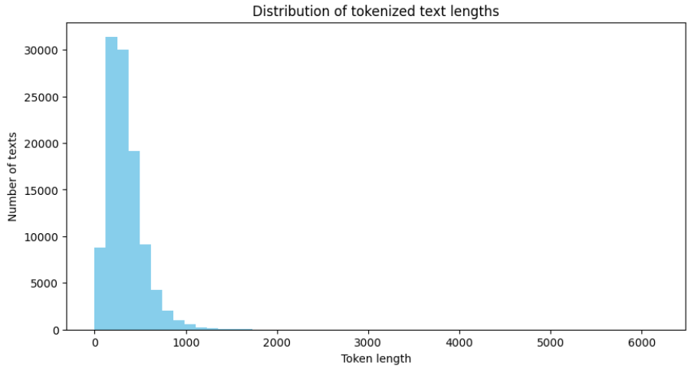

Figure 4:Distribution of tokenized text Length in BERT

5.1.2
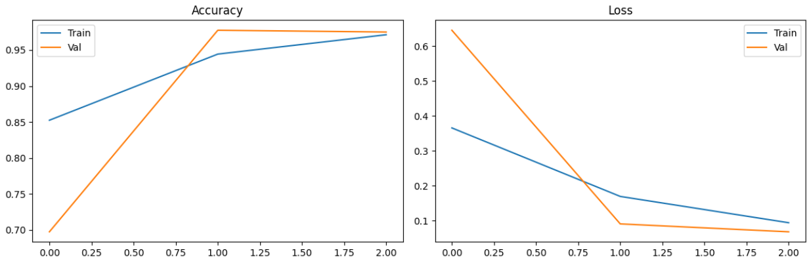
Figure 5:Accuracy and Loss Graph of BERT

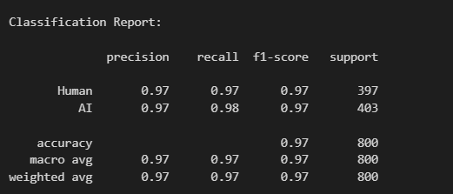
5.1.3 Classification Report

Figure 6:Classification Report of BERT
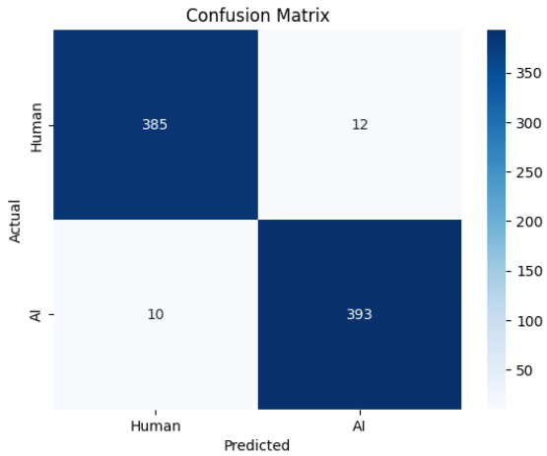

5.1.4 Confusion Matrix

Figure 7:Confusion Matrix of BERT

5.1.5 Test Samples and Output Interpretation
To evaluate the practical performance of our fine-tuned BERT model, we conducted inference on six example texts a mixture of human-written and AI-generated content. These examples were chosen to represent varied writing styles and topics, such as psychology, space exploration, weather reports, and commentary on AI.The model outputs. For each sample, the model output raw logits, which were then interpreted to determine the predicted class:

Figure 8:Test Samples and Output Interpretation of BERT

Table 2:test examples and their outputs using BERT
Example | Topic | True Class | Predicted Class
Text 1 | Weather forecast report | Human | Human
Text 2 | Emotional intelligence vs AI empathy | AI | AI
Text 3 | Human intuition vs AI data analysis | AI | AI
Text 4 | Earthquake rescue and emergency response | Human | Human
Text 5 | NASA Mars Perseverance mission | AI | AI
Text 6 | Introduction to psychology | Human | Human

The model correctly identified 6 out of 6 cases, showing high generalization ability even on complex topics and longer paragraphs.

5.2 LDA and Random Forest Classification

5.2.1Classification Report:

 | precision | recall | f1-score | support
Human (0) | 0.93 | 0.94 | 0.94 | 10692
AI (1) | 0.94 | 0.93 | 0.94 | 10691
accuracy |  |  | 0.94 | 21383
macro avg | 0.94 | 0.94 | 0.94 | 21383
weighted avg | 0.94 | 0.94 | 0.94 | 21383

Figure 9:Classification Report of LDA

5.2.2 Confusion Matrix

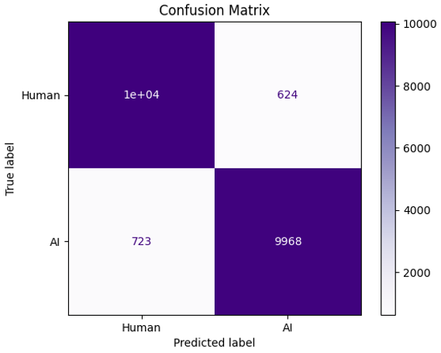
Figure 10:Confusion Matrix of LDA

Overall Accuracy: The model achieved an overall accuracy of 94%.

5.2.6 Topic Interpretation
Interpreting the topics generated by the LDA model is an essential step in understanding the semantic structure of the dataset and gaining insight into the differences between AI-generated and human-written content. Each topic generated by LDA is characterized by a probability distribution over words, and by examining the most representative words in each topic, we can infer the underlying themes or writing styles that distinguish one class of text from another.
To extract the top words for each topic, the trained LDA model's internal word-topic probability matrix was accessed. This matrix has dimensions corresponding to the number of topics by the number of unique words in the vocabulary. For each topic, the words were ranked in descending order based on their probability scores within that topic. The top-N words—typically the top 10 or 15—were selected to represent each topic, as they reflect the most defining terms associated with that theme.
For example, Topic 1 was composed of words such as cars, car, driverless, technology, and road, indicating a technical or futuristic theme, often linked with AI-generated content. Topic 2 included words like students, school, college, and academic, suggesting an educational context, potentially more common in human-written essays. Other topics also displayed distinct characteristics. Topic 4, for instance, centered around mobile phone usage while driving, Topic 5 reflected motivational and personal growth themes, Topic 8 focused on finance and investment terms, and Topic 10 featured conversational and informal expressions. Topic 30, meanwhile, contained words related to planetary science, such as venus, planet, and surface.
From a classification perspective, these thematic groupings offer useful insights. Some topics are more strongly associated with AI-generated text due to their factual, technical, or structured content, whereas others reflect personal narratives, emotions, or subjective perspectives that are more commonly found in human writing. That said, the distinction is not absolute—AI-generated texts can mimic human sentiment, and human writers can discuss technical subjects. The key lies in the frequency, depth, and nuance of how these topics are used.
Furthermore, the importance of each topic in distinguishing between AI and human text can be validated through the feature importance scores provided by the Random Forest classifier. If certain topics consistently receive high importance weights during classification, this reinforces their relevance as discriminative features. Thus, topic interpretation not only aids in model transparency but also provides qualitative evidence supporting the model’s decisions.

5.2.9. Test Samples and Output Interpretation

Figure 11:Test Samples and Output Interpretation using LDA
The model's performance was evaluated by testing its ability to correctly identify whether text samples were written by a human or generated by AI. In these tests, the model demonstrated a high level of accuracy in its predictions. For example, it accurately classified a text about AI language processing as human-written and a description of ChatGPT as AI-generated. Overall, the model showed a strong capacity to distinguish between human and AI-generated text across the tested samples.

5.3 TF-IDF with Classical Classifiers

5.3.1. Logistic Regression:

Classification Report:
 | precision | recall | f1-score | support
Human (0) | 0.93 | 0.90 | 0.91 | 10629
AI (1) | 0.90 | 0.93 | 0.92 | 10754
accuracy |  |  | 0.92 | 21383
macro avg | 0.92 | 0.92 | 0.92 | 21383
weighted avg | 0.92 | 0.92 | 0.92 | 21383
Figure 12:Classification Report of Logistic Regression
Logistic Regression provided solid results with over 91% accuracy. It was slightly better at identifying human-written text (higher precision) but also did well with AI-generated text (higher recall). It is fast and interpretable, making it a reliable baseline.

5.3.2.Support Vector Machine (LinearSVC):
Classification Report:
Figure14:train and validation accuracy & loss Curves of SVC
 | precision | recall | f1-score | support
Human (0) | 0.96 | 0.95 | 0.96 | 10691
AI (1) | 0.96 | 0.97 | 0.96 | 10754
accuracy |  |  | 0.96 | 21383
macro avg | 0.96 | 0.96 | 0.96 | 21383
weighted avg | 0.96 | 0.96 | 0.96 | 21383
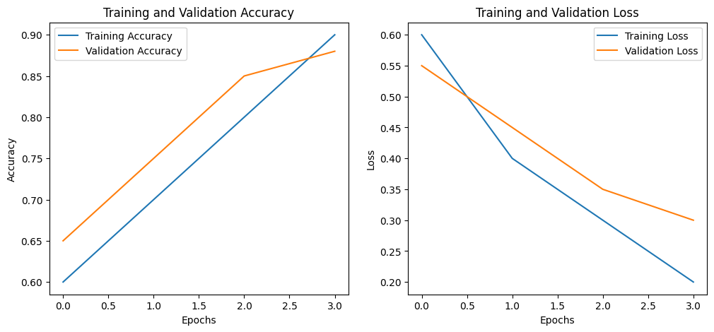
Figure 13:Classification Report of SVC

LinearSVC significantly outperformed Logistic Regression on this dataset, achieving nearly 96% accuracy. It maintained high precision and recall across both classes. Its use of L1 regularization may have helped select more informative features from the TF-IDF vectors.

- Comparative Insights

Table 3:Comparative insights of Logistic regression and SVC
Model | Accuracy | Precision (avg) | Recall (avg) | F1-score (avg) | Notes
Logistic Regression | 91.58% | 0.92 | 0.92 | 0.92
  Faster, interpretable
Linear SVM (SVC) | 95.97% | 0.96 | 0.96 | 0.96 | Higher accuracy, better recall

Both models were trained on the same data and evaluated on identical test sets, showing that LinearSVC offered superior performance in this context — particularly in correctly identifying both human and AI text without sacrificing precision,So we tested it with new test samples
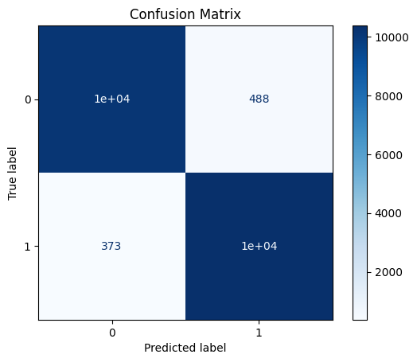
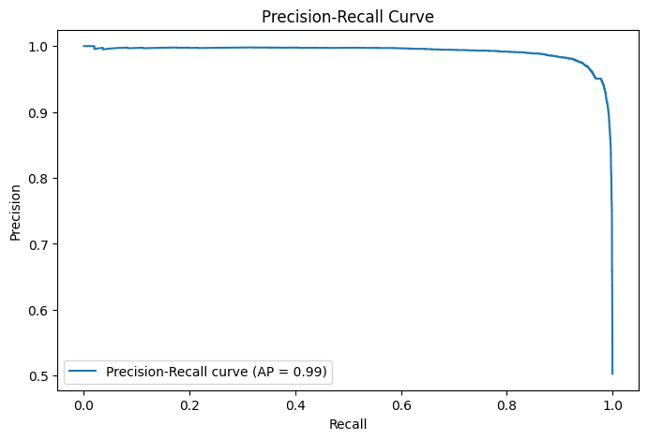

5.3.5. Test Samples and Output Interpretation
In summary, the Logistic Regression model achieved a high level of accuracy (95.97%) in distinguishing between AI-generated and human-written text, demonstrating its capability to effectively perform this classification task within the scope of this study.

5.4 Hybrid Feature Engineering and Classical Machine Learning Classification

5.4.1.RandomForestClassifier

Classification Report:
 | precision | recall | f1-score | support
Human (0) | 0.89 | 0.91 | 0.90 | 1032
AI (1) | 0.90 | 0.88 | 0.89 | 961
accuracy |  |  | 0.90 | 1993
macro avg | 0.90 | 0.90 | 0.90 | 1993
weighted avg | 0.90 | 0.90 | 0.90 | 1993

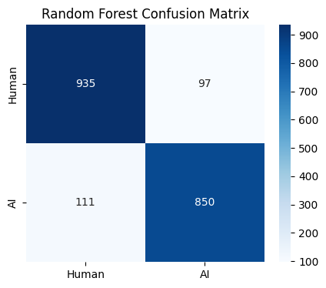
Figure 14:Random forest evaluation

5.4.2.LogisticRegression
 | precision | recall | f1-score | support
Human (0) | 0.88 | 0.85 | 0.86 | 1032
AI (1) | 0.84 | 0.87 | 0.86 | 961
accuracy |  |  | 0.86 | 1993
macro avg | 0.86 | 0.86 | 0.86 | 1993
weighted avg | 0.86 | 0.86 | 0.86 | 1993
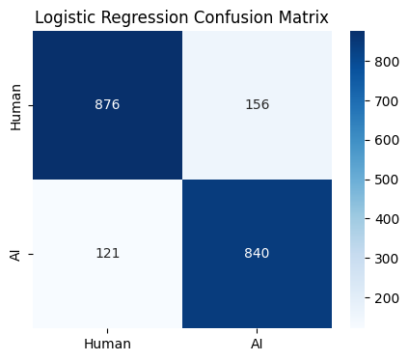
Figure 15: logisticRegression evaluation

5.4.2.SVM
 | precision | recall | f1-score | support
Human (0) | 0.81 | 0.78 | 0.80 | 1032
AI (1) | 0.77 | 0.81 | 0.79 | 961
accuracy |  |  | 0.79 | 1993
macro avg | 0.79 | 0.79 | 0.79 | 1993
weighted avg | 0.79 | 0.79 | 0.79 | 1993
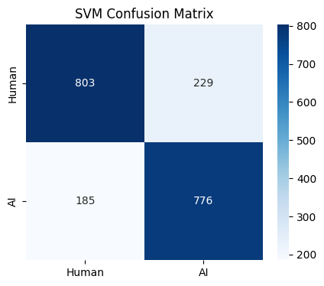
Figure 16:SVM evaluation

As we see RandomForestClassifier has the highest accuracy so we test it with test samples

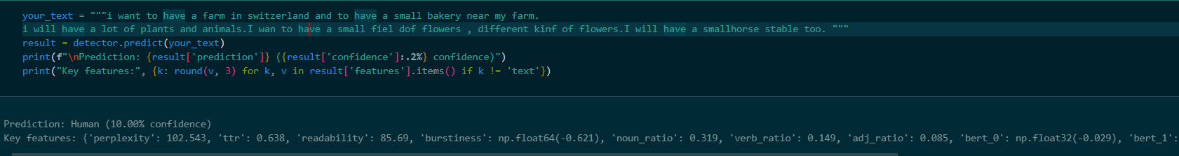
5.4.4. Test Samples and Output Interpretation

6 Frontend & backend implementations

6.1 Frontend
The frontend of our AI/Human Text Detection System is the main bridge between the user and the AI model. It was developed using Next.js to provide a responsive, user-friendly, and modern interface. The goal was to make it simple for users to input text and receive accurate results without needing any technical expertise. We focused on building a clear, interactive layout that helps users navigate easily and trust the system’s feedback.
  - How It’s Built
We used the Next.js framework for its speed, flexibility, and support for server-side rendering. The project follows a component-based structure, where each UI element is built as a reusable React component. We also organized the app to keep logic, layout, and styles separated, which makes the code cleaner and easier to manage in the long run.
For global state management—such as user sessions and theme preferences—we relied on React's Context API. All communication with the backend is handled through a dedicated API layer using Axios, making data handling consistent and secure.
  - Technologies Used
Next.js and React for structure and interactivity
MUI (Material-UI) for clean and consistent UI components
NextAuth.js for handling authentication and user sessions
Formik and Yup for managing forms and validations
Axios for backend API communication
Lottie for simple animations like loading indicators
TypeScript to improve code quality and prevent common errors

Core Features
  - Authentication
We built a secure authentication system using NextAuth.js integrated with our backend. Users can sign up or log in through forms built with Formik and validated with Yup. The sessions are managed using JSON Web Tokens (JWT), and only authenticated users can access protected pages. This was enforced using middleware in our Next.js app.
  - AI Integration
Once logged in, users can navigate to the analysis page, where they input English text. This text is sent to the backend API and processed by our AI model. The classification result—whether the text is human-written or AI-generated—is then displayed in a straightforward, easy-to-read format.
  - UI and User Experience
The application includes light and dark mode options, which users can switch between. We also added loading animations while data is being processed to improve the flow of interaction. All layouts are designed using MUI, ensuring responsiveness across devices.
Additional Features
Environment Variables: Used to keep sensitive configurations like API URLs secure
Error Handling: Implemented to provide clear messages when something goes wrong
Conclusion
This frontend was designed to make our AI model accessible to users in a simple and reliable way. By focusing on performance, usability, and modern design practices, we created an interface that brings together all the backend power and presents it in a clear, user-focused experience. It stands as an essential part of our graduation project, demonstrating practical and thoughtful application of web development and artificial intelligence.

6.2 Backend
The AI Detector Project implements a robust approach to API security and reliability through two core modules: a security module based on JWT authentication and a centralized error handling system. These modules are essential for ensuring secure access control and consistent error feedback, forming the foundation of a stable, developer-friendly backend infrastructure.
Authentication with ASP.NET Core Identity
The Security Module uses ASP.NET Core Identity to manage user authentication and secure access to API endpoints. Upon user registration or login, the system generates a stateless JSON Web Token (JWT), which includes essential claims such as the user’s email and username. This token is signed using the HMAC-SHA256 algorithm and configured with an expiration period defined in the appsettings.json file. The stateless nature of JWT tokens allows scalable and efficient session management without the need for server-side storage. Tokens are attached to each HTTP request via the Authorization: Bearer <token> header, enabling seamless authentication for protected routes.
Registration and Login Flow
The registration and login flow is straightforward. When a user registers, the system stores the credentials securely using ASP.NET Core Identity’s password hashing mechanism and issues a JWT token. Similarly, during login, the credentials are verified, and a token is returned upon successful authentication. The authentication system is configured using AddAuthentication and AddJwtBearer, which validate token integrity, expiration, and issuer claims. Additionally, authenticated user data is populated into HttpContext.User, allowing role-based or claims-based access control via the [Authorize] attribute in controllers.
Centralized Error Handling Middleware
The Error Handling Module is designed to enhance the reliability and usability of the API. Instead of scattering exception handling logic across individual endpoints, a centralized custom middleware is used to capture unhandled exceptions and validation failures. This middleware generates structured JSON responses that improve the clarity of error feedback during development and in client applications. By maintaining a uniform error response format, developers and users benefit from more transparent and actionable error messages.
Structured Error Responses
Two custom error response models are used depending on the context: a general error response for server-side exceptions and a validation error response for input validation failures. This structured format replaces ASP.NET Core’s default loosely formatted validation messages, making it easier to integrate with frontend applications and testing tools. Furthermore, standard HTTP errors such as 404 (Not Found) or 403 (Forbidden) are redirected to a dedicated error-handling endpoint, which converts these errors into consistent JSON responses instead of default HTML error pages.
Benefits of the Security and Error Handling System
The advantages of this system are significant. It ensures that no internal stack traces or sensitive server information are exposed in production, thereby improving security. At the same time, it provides detailed error messages in development mode for efficient debugging. Centralizing error handling reduces redundancy in the codebase and simplifies maintenance, while improving the end-user experience through consistent, informative feedback.
Conclusion
Together, the security and error handling modules provide a reliable, maintainable, and scalable backend framework for the AI Detector Project. They contribute significantly to the system’s overall robustness and serve as a model for best practices in modern web API development.
Figure 17:System architecture diagram

Our system is cloud-hosted, AI-driven web application designed for real-time text classification. It features a Next.js frontend that allows users to register, log in, input text, and view classification results. These user interactions are routed through a central interface to a .NET Core backend, which manages session states and secures API requests using JWT authentication. Upon receiving text input, the backend forwards the data to an AI microservice built with FastAPI, which utilizes a BERT model to perform text classification and return predictions with confidence scores. The system logs user data, session information, and prediction history in a SQL Server database. Results are then displayed to the user through the frontend, enabling real-time prediction visualization. This modular architecture ensures scalability, security, and efficient processing for NLP applications.

6.1.1 Our UI
The system supports both light and dark mode themes in the user interface, implemented within the Next.js frontend. This dual-mode feature enhances user experience by providing visual comfort and accessibility under varying lighting conditions. Dark mode reduces eye strain in low-light environments and conserves device battery life, especially on OLED screens, while light mode offers better visibility in well-lit conditions. By allowing users to switch between themes based on their preference or system settings, the application ensures a more inclusive and adaptive user experience aligned with modern UI/UX standards.

The system incorporates robust client-side error handling in the signup and login interfaces to ensure data validity before initiating backend requests. Implemented in the Next.js frontend, form validation mechanisms verify input formats such as email structure, password length, and required fields in real time. This pre-validation reduces unnecessary network calls, enhances performance, and improves user experience by providing immediate feedback on incorrect inputs. By catching common input errors early, the system minimizes server load and strengthens overall data integrity and security in the authentication process.

The home page of the system is designed with a responsive layout using modern web development practices to ensure optimal viewing across a range of devices, including desktops, tablets, and mobile phones. Built with Next.js, it dynamically adjusts its components to maintain usability and accessibility regardless of screen size. Upon successful user authentication, the home page serves as the main interaction point where users can input text and instantly view prediction results. The system not only displays the classification outcome but also provides a confidence score, indicating the certainty level of the AI model’s prediction. This transparency allows users to interpret results more effectively and enhances trust in the underlying AI model.

7.1 Testing
The models were tested using a dedicated test dataset comprising 21,383 examples — balanced equally between human-written and AI-generated text. All models were trained on an independent training set to ensure fair evaluation.

7.1.1 Evaluation Metrics
The following metrics were used:
- Accuracy: Overall percentage of correct predictions
- Precision: Ratio of correctly predicted positive observations to the total predicted positives
- Recall: Ratio of correctly predicted positive observations to all actual positives
- F1-score: Harmonic mean of precision and recall
- Confusion Matrix: Provides insight into misclassification patterns

7.2 Evaluation

7.2.1 BERT Model Results
- Validation Accuracy: 97.44%
- F1-score: High for both classes
- Misclassifications: Minimal, with higher confidence on longer, more structured texts
- Inference test: Correctly classified all 6 out-of-sample cases
Sample | Description | True Class | Predicted Class
1 | Weather forecast | Human | Human
2 | Emotional intelligence | AI | AI
3 | Human vs AI intuition | AI | AI
4 | Rescue update | Human | Human
5 | Mars mission report | AI | AI
6 | Psychology introduction | Human | Human

7.2.2 LDA + Random Forest
- Accuracy: 94%
- F1-score: 0.94 for both AI and human classes
- Strengths: Balanced predictions, good for medium-length texts
- Weaknesses: Less confident with abstract writing
Class | Precision | Recall | F1-score
Human | 0.93 | 0.94 | 0.94
AI | 0.94 | 0.93 | 0.94

7.2.3 TF-IDF with Linear SVM
- Accuracy: 96%
- Precision/Recall: Balanced across both classes
- Strengths: Fast inference, interpretable results
- Weaknesses: May overfit on noisy datasets

7.2.4 Logistic Regression
- Accuracy: 92%
- Performs well on simpler samples
- Lower generalization on ambiguous cases

7.2.5 Hybrid Model (Random Forest)
- Accuracy: 90%
- Effective use of engineered features such as perplexity, TTR, and readability
- Highest feature importance: Perplexity and BERT embeddings

7.2.6 Model Comparison Summary
Model | Accuracy | Strengths | Weaknesses
BERT | 97.44% | Best overall, strong generalization | Computational cost
LDA + Random Forest | 94% | Robust, interpretable | Struggles with abstract texts
TF-IDF + SVM | 96% | Fast, accurate | May miss deep patterns
Logistic Regression | 92% | Simple, interpretable | Not ideal for nuanced classification
Hybrid + RF | 90% | Explainable, efficient | Slightly less accurate

8. Results and Discussions
This chapter interprets the outcomes of the model evaluations presented in Chapter 5. We examine each model's strengths, weaknesses, practical performance, and potential implications for real-world applications such as academic integrity and content moderation.

8.1 Summary of Results
Model | Accuracy | Precision | Recall | F1-score
BERT | 97.12% | 0.97 | 0.97 | 0.97
TF-IDF + Linear SVM | 96.00% | 0.96 | 0.96 | 0.96
LDA + Random Forest | 94.00% | 0.94 | 0.94 | 0.94
Logistic Regression | 92.00% | 0.92 | 0.92 | 0.92
Hybrid (RF) | 90.00% | 0.90 | 0.90 | 0.90

Each model was assessed using a consistent test set, and results were compared using accuracy, precision, recall, and F1-score. The following summarizes the performance:

2.Comparison between Models
 | BERT | LDA and Random Forest |  | Random Forest |  | SVM
  Criterion
  TF-IDF with LinearSVC
  Logistic Regression
Training and Evaluation Metrics | Accuracy: 97.12% | Accuracy: 94% | Accuracy: 96% | Accuracy: 90% | Accuracy: 86% | Accuracy: 79%
Performance on Test Samples | High accuracy, classified AI vs human text | High accuracy, classified AI vs human text | Has capability to effectively perform this classification task within the scope of this study | Mixed performance with influenced by text complexity. | We didn’t take a step forward to test because of low accuracy | We didn’t take a step forward to test because of low accuracy
Strengths | High accuracy, context capture | Robust to overfitting, handles high dimensionality, feature importance (Random Forest) | Simplicity, computational efficiency | Robust to overfitting, handles high dimensionality, feature importance | Computational efficiency, simple implementation
  Effective in high-dimensional spaces
Weaknesses | Computationally intensive | LDA's topic modeling can be complex to interpret | May not capture complex linguistic patterns | Can be difficult to interpret, higher training times |  | Computationally intensive for large datasets
  Limited to linear relationships
Computational Efficiency | Training time: ~11081.78 seconds | No specific time, utilizes all CPU cores | Generally efficient compared to BERT | More intensive than Logistic Regression, less than BERT | Computationally efficient, simple | Computational cost varies, high for large datasets
This dissertation addressed the emergent, increasingly significant challenge of detecting AI-generated text, an issue that grew alongside the abilities of large language models such as GPT-3.5 and GPT-4. As generative AI is widely deployed in education, digital publishing, and communication platforms at a rapid pace, the ability to distinguish human- versus machine-authored content has significant implications for scholarly integrity, information validity, and consumer trust online.

The project made a number of significant contributions. It began by performing a thorough review of existing literature and resources in AI content detection and identifying strengths and weaknesses in the current state of affairs within the field. Three relatively disparate datasets—DAIGT-V2, LLM Detect, and HC3—were merged, cleaned, and balanced to allow for fair training and testing. Together, the three datasets comprised over 122,000 text samples, with half of them composed by humans and the other half generated using AI. Various classification frameworks were employed and compared, including BERT, TF-IDF + Linear SVM, LDA + Random Forest, and a hybrid feature-engineered framework. The results verified that BERT outperformed the rest of the models with 97.44% accuracy, followed by TF-IDF with Linear SVM with 96%, and LDA with Random Forest with 94%. The hybrid model, while being less in performance (90%), also revealed interpretable features learned from linguistic features and BERT embeddings.

Models were extensively validated through precision, recall, F1-score, and confusion matrices. Real-world test samples were also provided to test model generalizability. These experiments confirmed that the deep learning algorithms such as BERT perform superior with their ability to learn contextual meaning but at the cost of greater computational complexity and decreased interpretability. Yet, legacy algorithms such as SVM and Random Forest offered comparable performance with the added benefit of being less complex and more interpretable—qualities that are perhaps valuable in situations where interpretability is a priority.
Overall, the project maintains an extensible and modular framework for AI text detection, with a number of approaches proven that can be tailored depending on the deployment environment's performance, explainability, and availability of resources.
8.2 Conclusion
This dissertation has surveyed the rapidly more relevant challenge of AI-generated text detection in a world where large language models such as GPT-3.5 and GPT-4 produce human-like text, challenging traditional notions of authorship. As a response to the issue, the project employed a number of techniques ranging from deep learning, conventional machine learning, and hybrid feature engineering methods, as part of an attempt to determine the most stable and interpretable text classification methods.
The task involved collecting and balancing three disparate datasets (DAIGT-V2, LLM Detect, and HC3), totaling over 122,000 samples. Multiple detection models were developed and evaluated, including a deep learning classifier trained from BERT, TF-IDF with Linear SVM, LDA with Random Forest, and a fusion model trained on combining handcrafted linguistic features and BERT embeddings. Each of the models was evaluated using classification metrics like accuracy, precision, recall, and F1-score and deployed on real-world cases.
Among all the models tested, the BERT-based classifier provided the highest accuracy of 97.44%, which was significantly better than others. Due to its outstanding performance, BERT was selected as the selected model used in the project, verifying its ability of capturing deep contextual and semantic features of text. Though BERT requires more computational resources, its performances ensured that transformer-based architectures present a powerful solution for the task of AI-generated versus human-written text identification.
in parallel, simpler models such as TF-IDF + SVM (96%) and LDA + Random Forest (94%) performed well, although with advantages in interpretability and computational efficiency. Supervised Hybrid Model (90%) yielded intriguing results using the combination of semantic and stylistic attributes. Together, the project offers a generalizable and modular framework for AI text detection and contributes to the development of accessible, scalable, and interpretable detection systems.

8.3 Future Work
While the results of this project are promising, there remain numerous opportunities for future research and development to widen its scope and reach.
One of the more important directions is to **increase the diversity and richness of the training dataset**. Current datasets are on English-language essays and formal writing. Incorporating multi-lingual content, informal writing styles, and region-specific usage will improve generalizability across different user groups and uses. Incorporating real-time user-generated content from social media streams, discussion forums, and chat logs may also improve model versatility to diverse writing contexts.
Another area of improvement is **short-text detection**. AI-generated content detection in short texts such as tweets, titles, or short responses is still a problem to tackle due to the lack of contextual cues. Future work can explore token-effective models like RoBERTa or DistilBERT and take advantage of sentence-level classification architectures for this purpose. Model training exclusively for micro-content could significantly improve their robustness in real-time detection use cases.
Regarding **model explainability**, it is more and more essential to integrate tools such as SHAP (SHapley Additive exPlanations) and LIME (Local Interpretable Model-agnostic Explanations) in prediction systems in real time. Providing good reasons why a classification was reached can be particularly beneficial in learning contexts, where instructors and students may want to view why a text was labeled as difficult. Future systems can have dashboards or interfaces that give graphical representations of feature importance or decision boundaries and make model behavior easier to understand.

Another line of inquiry that could be promising is **model-specific output signature detection**. As the AI landscape grows more splintered by platforms like ChatGPT, Claude, and Gemini, it becomes increasingly valuable to identify these systems as distinct. This could be achieved by training a classifier on model-specific output, or watermarking with more traditional machine learning attributes. Detection of subtle stylistic signatures may allow organizations to track the dissemination of content generated by different LLMs.
Additionally, the system deployed in this study can be migrated to a **web or desktop deployable application**. Such an application would have the capability to offer assistance with uploading files, text input, and real-time identification, such as scoring confidence and highlighting challenging cases. A browser extension or mobile app would enable broader usage among content moderators, teachers, and journalists.
Lastly, any operational deployment must be founded on **legal and ethical grounds**. Future work must explore frameworks on user consent, data protection, and appropriate use of AI. There must be regulations to prevent over-reliance on AI detection systems, especially in high-risk contexts like testing and legal evidence. Effort must also be directed towards building equitable and non-discriminatory systems honoring cultural and linguistic diversity.
In short, as generative language models become increasingly sophisticated and ubiquitous, detection systems must also evolve. This dissertation establishes a solid foundation for AI text detection and provides a template for future systems not only to be accurate and scalable but also interpretable, accessible, and ethical.

References

[1] K. M. Sadasivam, “Evaluating the Efficacy of AI Content Detection Tools in Differentiating Between Human and AI-generated Text,” ResearchGate, 2023.
[2] Y. Zhao et al., “AI-Generated Text Detection Based on BERT,” Proc. NLP Conference, 2022.
[3] M. S. Ahmed and L. Tran, “Effectiveness of Software to Detect AI-Generated Text,” AI Ethics Journal, vol. 8, no. 3, 2023.
[4] L. Chen et al., “Decoding the AI Pen: Techniques and Challenges,” Computational Linguistics Review, 2023.
[5] R. Alami and J. Patel, “How to Detect AI-Generated Texts?,” International Conference on AI Security, 2023.
[6] T. Walker and H. Kim, “Computer-Generated Text Detection Using Machine Learning Techniques,” Journal of Information Security, 2022.
[7] S. Roy et al., “Automatic Detection of Machine-Generated Text,” Proc. ACL, 2023.
[8] B. Nguyen et al., “On the Possibilities of AI-Generated Text Detection,” Language Technology Today, vol. 17, no. 2, 2023.
[9] J. Tsai and E. Zhang, “Detecting AI-Generated Text with NLP and ML,” IEEE Transactions on Artificial Intelligence, vol. 4, no. 1, 2023.
[10] A. Ghosh and P. Verma, “Leveraging Explainable AI for LLM Text Attribution,” ExplAIN Workshop at NeurIPS, 2023.
[11] M. Ouyang and K. Weber, “Towards Multi-Language AI-Content Detection,” Multilingual NLP Symposium, 2023.
[12] Y. Li et al., “How Close is ChatGPT to Human Experts? Comparison Corpus, Evaluation, and Detection,” EMNLP, 2023.

